# Milestone 1 – Deliverable 4 Detailed Tutorial

3b. Testing the Level

Drag your Player Object from Assets > Prefabs into Stage 1. When you drop Player at Stage 1, Player drops in as a child of Stage 1 and sibling (same level) as Game Borders and default Main Camera. Save your Project.

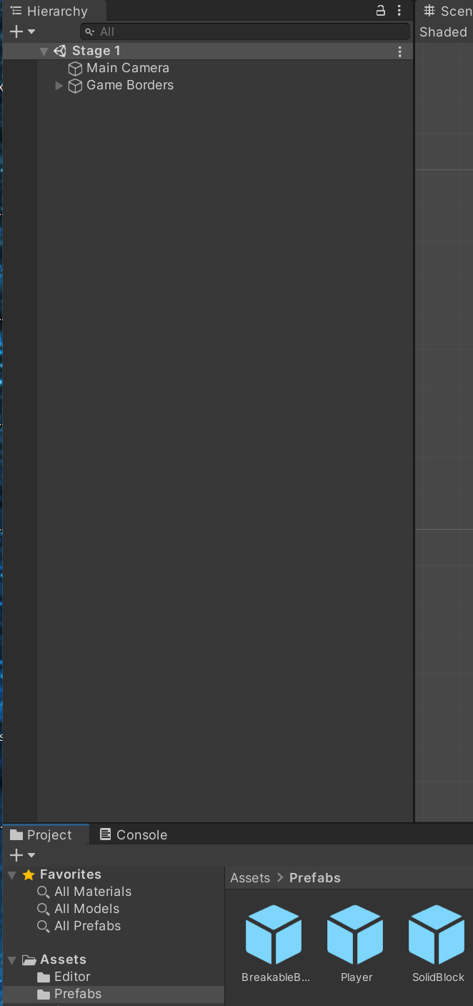 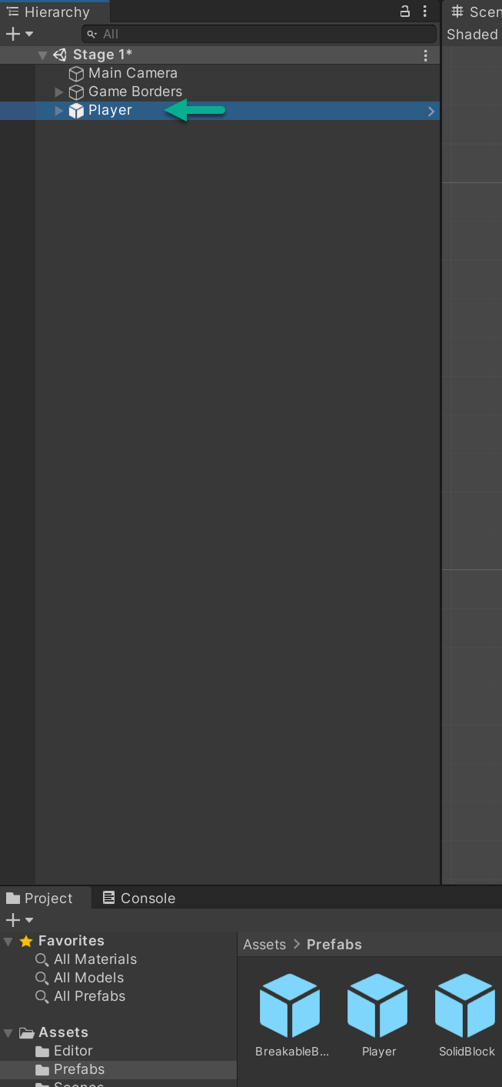

You can see the hierarchy of objects. Children of Player are PlayerSprite and Attack Hitbox (created earlier and reused here).

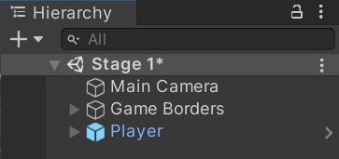 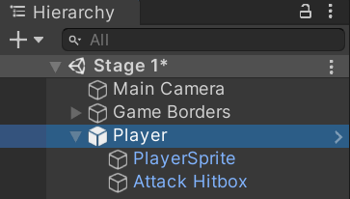

Select Player. Your Hierarchy and Scene should resemble:

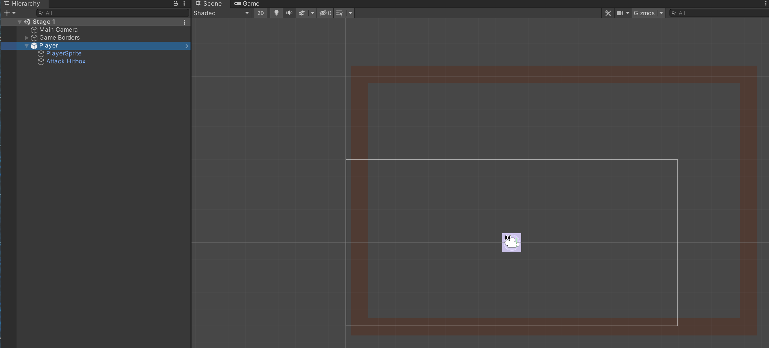

To test the game build has started, select the play button up top mid-screen above Scene. The Main Camera appears, and you will see Player drop down and stop at your bottom game border. Click play again to exit play mode.

You’re not yet playing; you will see some action in the Main Camera window that shows on scene.

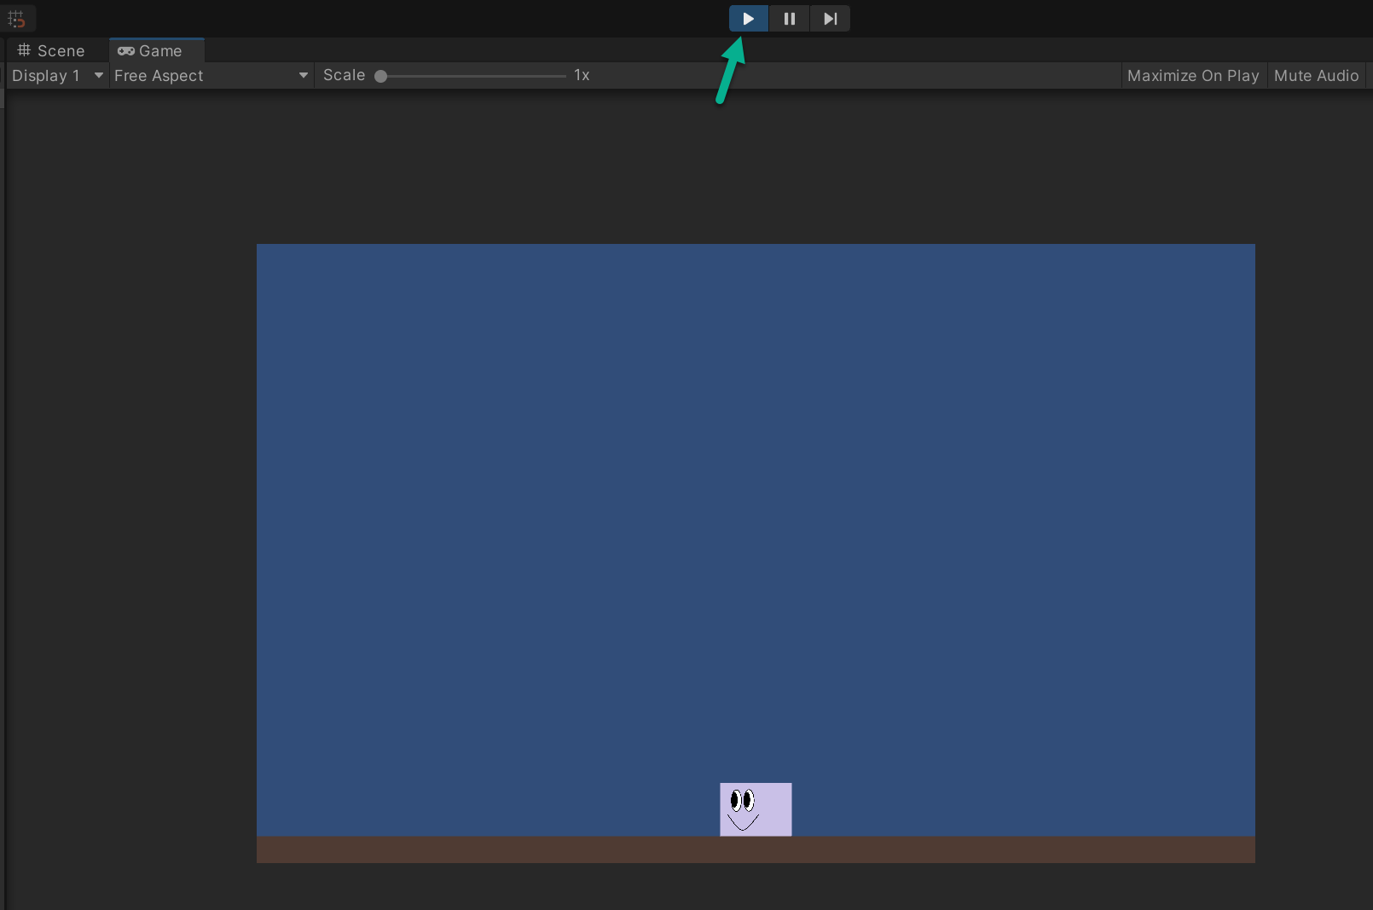

3c. Adding blocks

A combination of SolidBlocks and BreakableBlocks are for the Player to interact with.

* You won’t interact with breakable blocks at this point. You will design blocks within your borders. Later, you will add the rest of the functions into the scripts.
* You can move, jump, and check collisions with the ground and walls.
* As you create, make sure the Player is in the camera view because the camera follow script is not yet created. Select Main Camera inside Hierarchy and move it as you would a game object in game view.

Select Game Borders in Hierarchy to outline each of your Game Borders in green. At this point, yours looks like this:

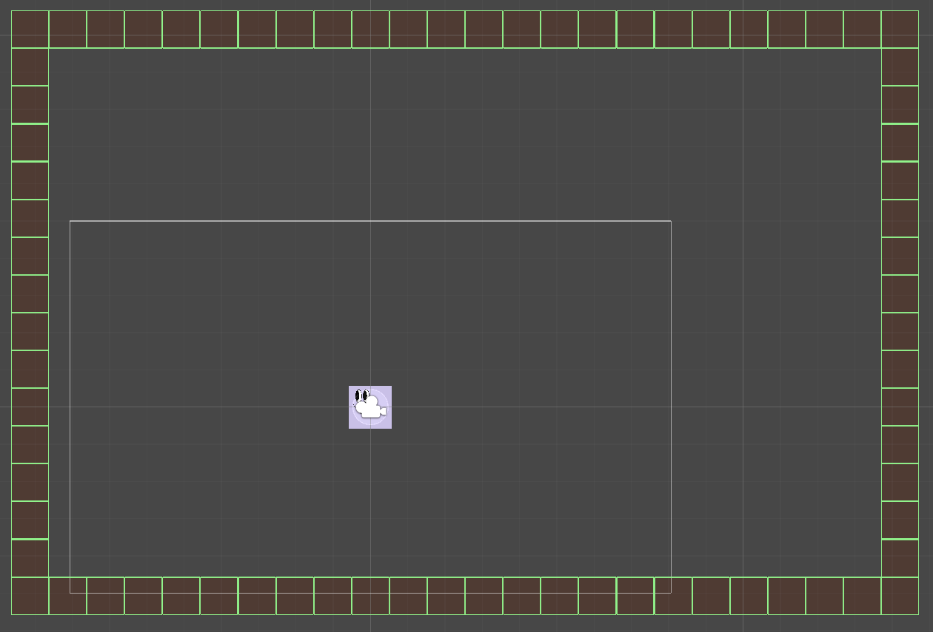

**Downey Platformer**

This image shows the example design from this tutorial.

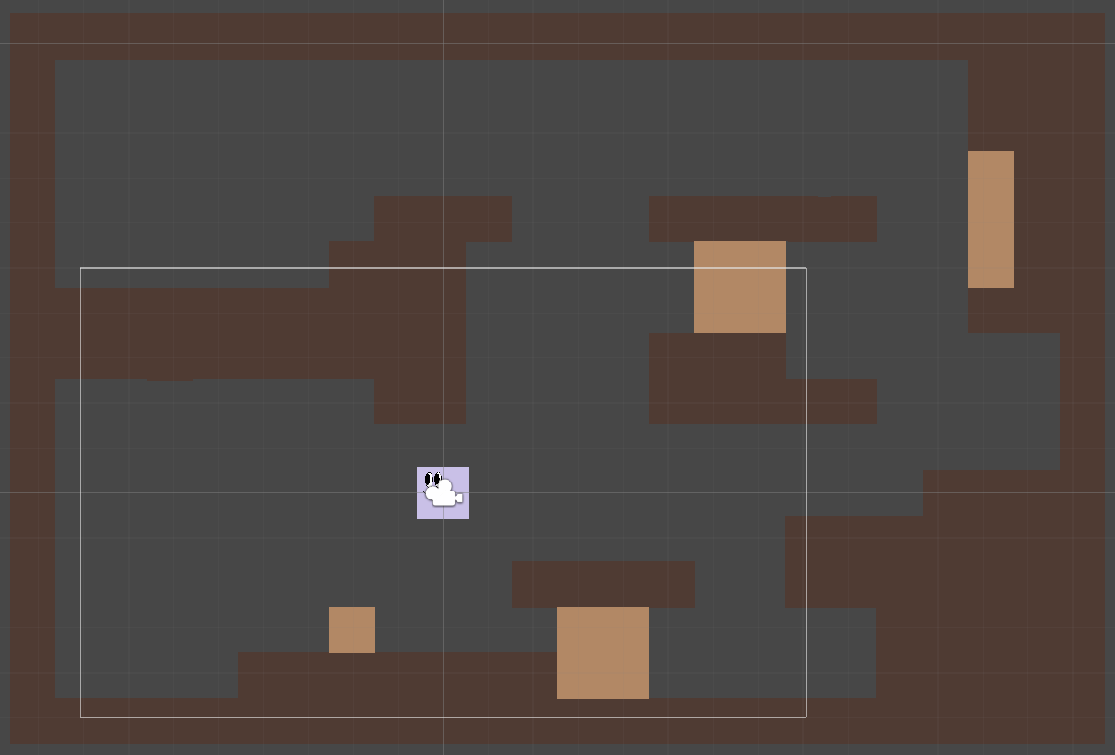

This image details Downey Platformer placement of new SolidBlock objects.

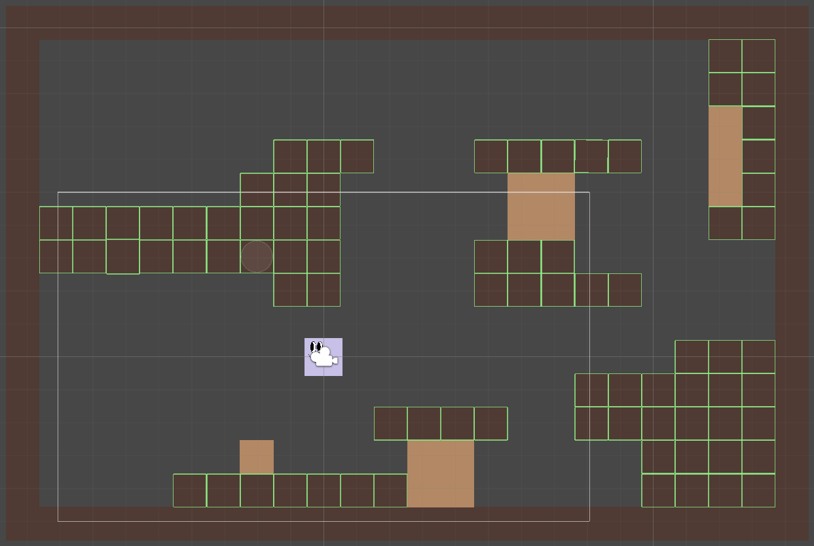

And this image details Downey Platformer placement of new BreakableBlock objects.

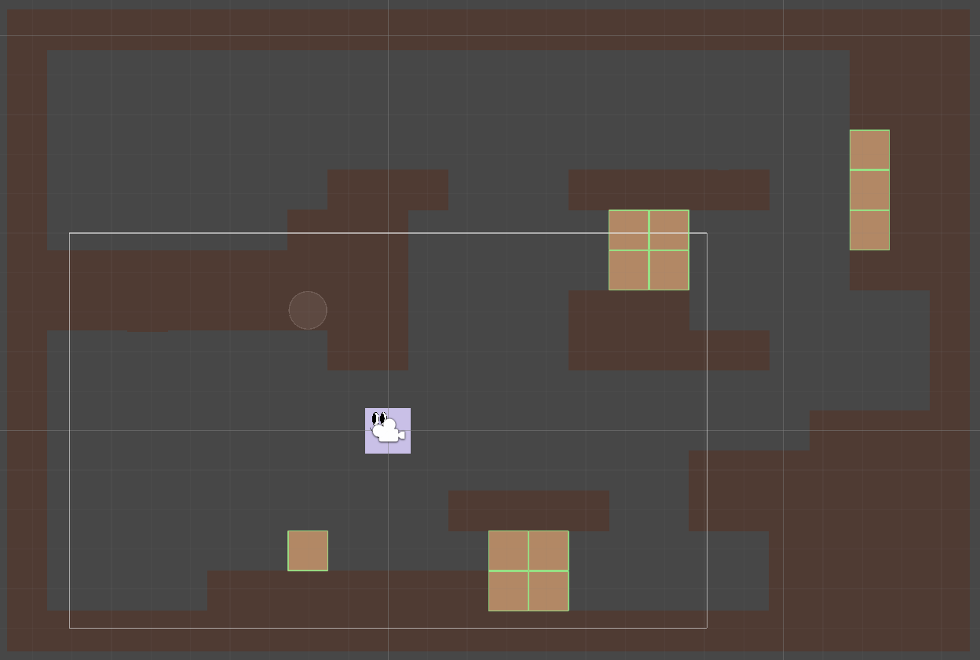

There’s no requirement for the order of objects when you set up your borders, SolidBlocks, and BreakableBlocks.

Consider other Platformer games:

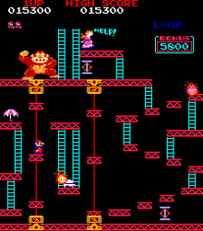

<https://en.wikipedia.org/wiki/Platform_game>

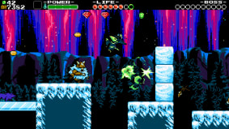

<https://www.nintendo.com/games/detail/shovel-knight-treasure-trove-switch/>



<https://www.sega.com/games/sonicmania>

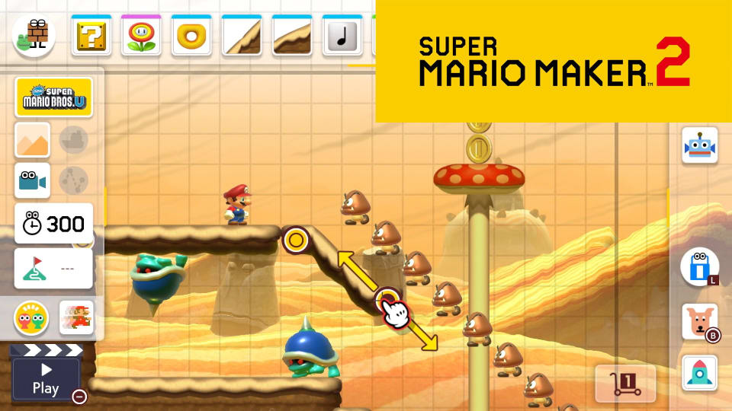

<https://www.nintendo.com/games/detail/super-mario-maker-2-switch/>

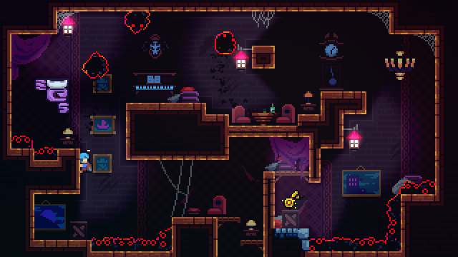

<https://www.nintendo.com/games/detail/celeste-switch/>

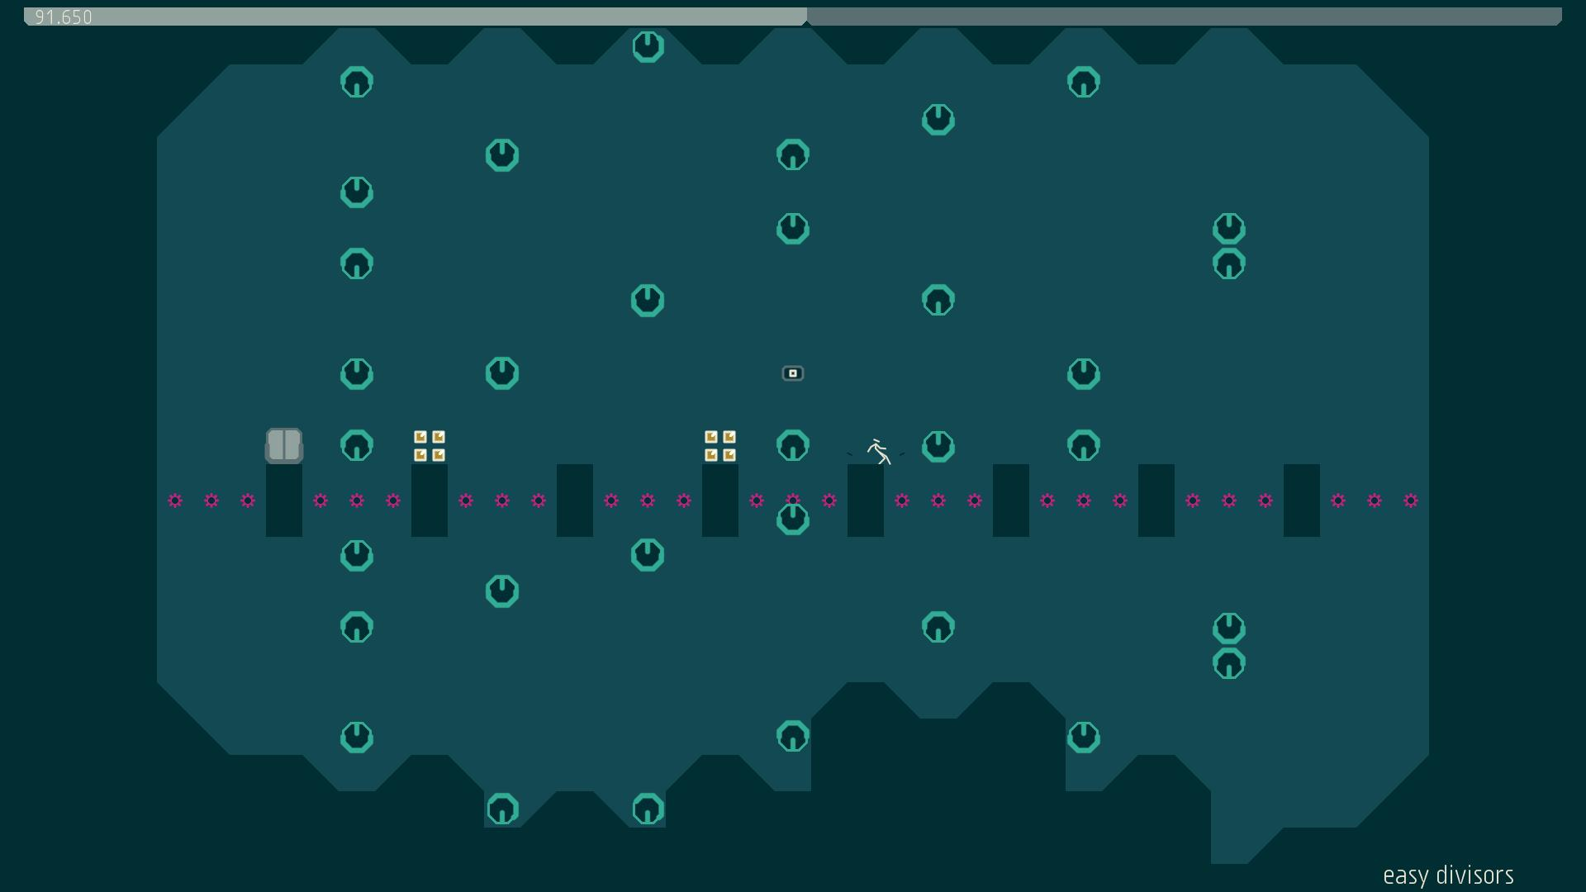

<https://nplusplus.org/>

You may want to sketch your own layout before you build. You can change blocks positions as your game evolves. This tutorial demonstrates how to build Downey Platformer. Don’t limit how you set up your Game Border dimensions or SolidBlock and BreakableBlock objects within borders. Do use the tutorial Prefabs because you will use them to build in more complexity over Milestones 1-4 (this tutorial is Milestone 1 Deliverable 4).

Save your project as you work.

Next up is to create interior walls for your player to navigate.

* In Hierarchy, right click and Create Empty > GameObject. Rename GameObject Solid Blocks
* In Hierarchy, right click and Create Empty > GameObject. Rename GameObject Breakable Blocks

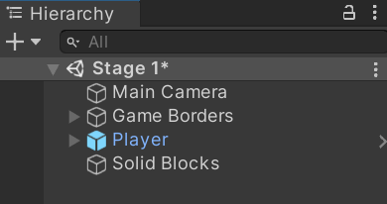 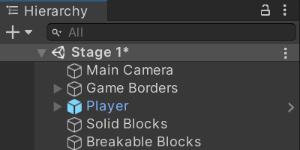

In Project, select Assets >Prefabs and drag the SolidBlock prefab inside Hierarchy to be a child object of Solid Blocks.

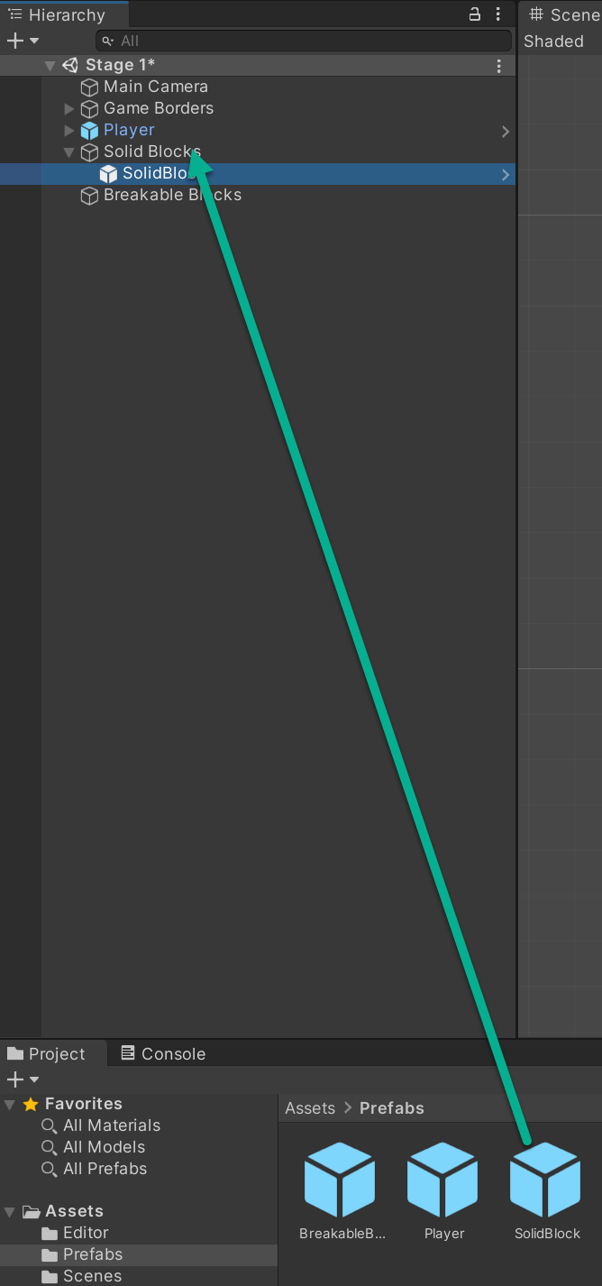

Select Solid Blocks > SolidBlock. In Sprite Renderer, change Color to hexadecimal 4F3B33

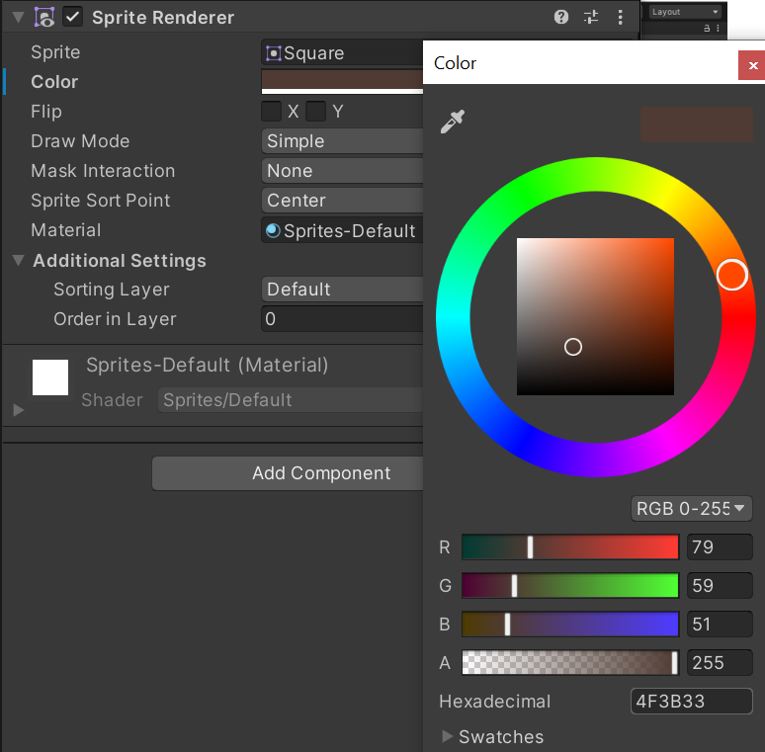

In Project, select Assets >Prefabs and drag the BreakableBlock prefab inside Hierarchy to be a child object of Breakable Blocks. Save your Project.

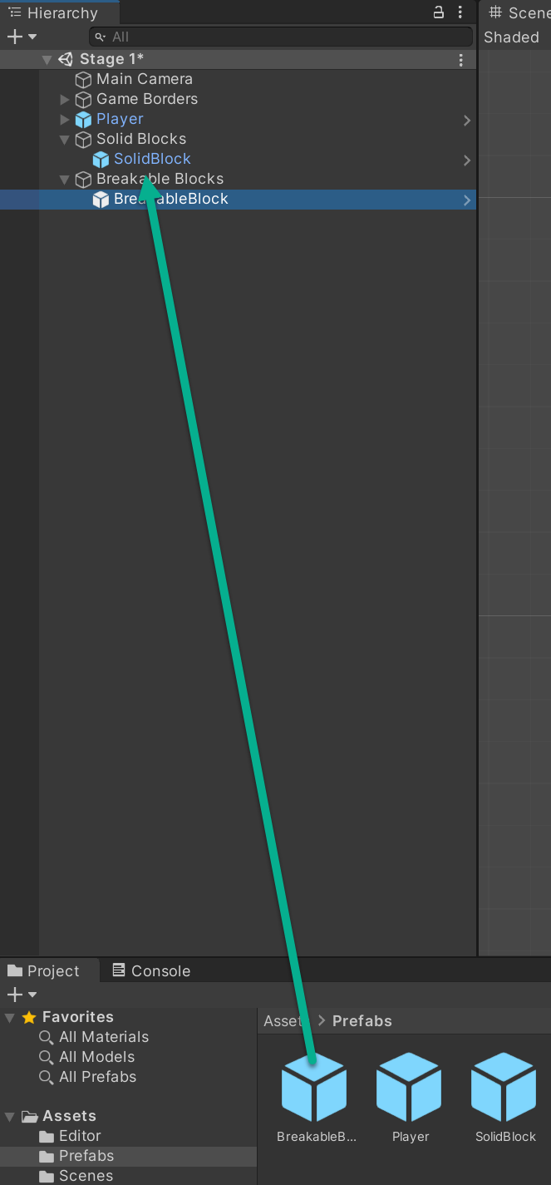

Select Breakable Blocks > SolidBlock. In Sprite Renderer, change Color to hexadecimal B28865

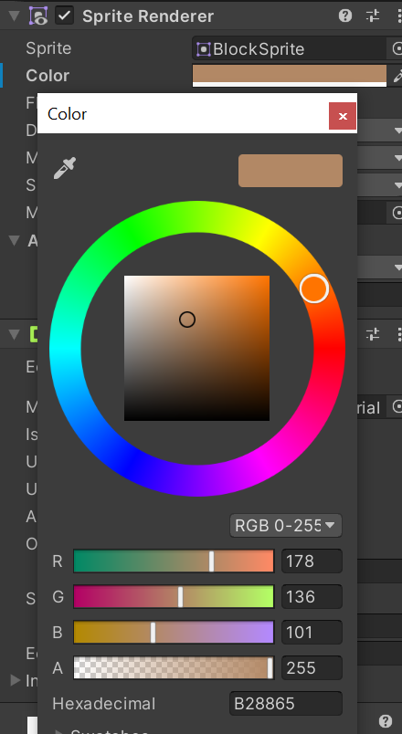

Move one of the blocks since they are at the same X Y coordinate to see both of your interior wall blocks. Save your Project.

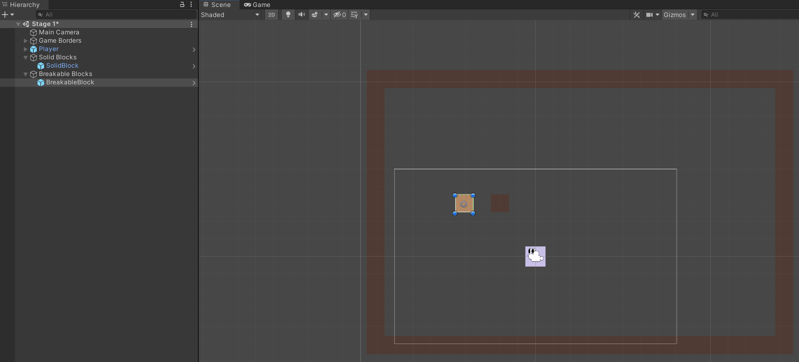

Select Solid Blocks > SolidBlock in Hierarchy and key Ctrl + D to duplicate SolidBlocks within the Solid Blocks object. This example uses 82 Blocks. Since computers start counting at zero, 82 blocks equate to SolidBlock through SolidBlock (81). Save your Project.

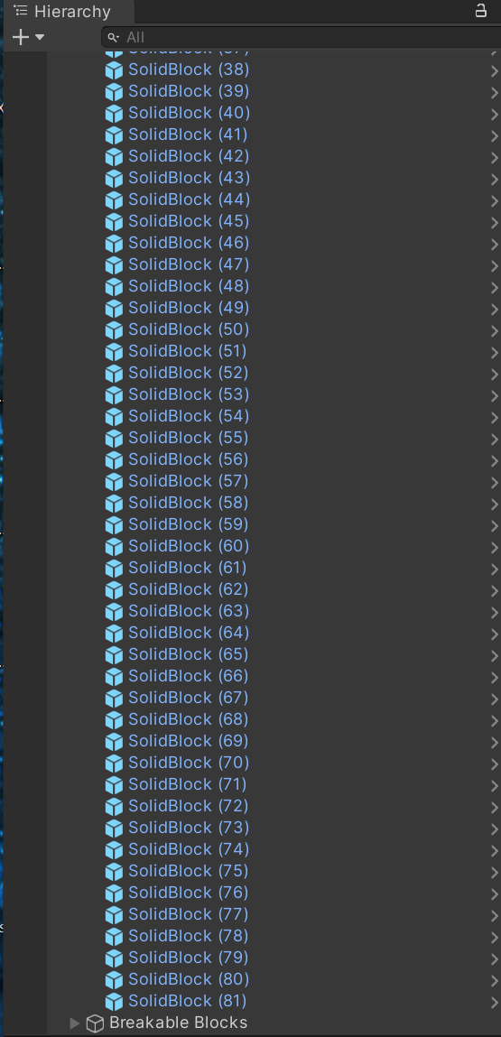

You may elect to complete SolidBlock in Scene before setting up BreakableBlock or create both and set up the Scene with both at the same time. Next, position every SolidBlock in the scene by selecting in Hierarchy and using the Rect Tool to move. Create the Downey Platformer Scene below or follow your ideas to inform the placement and the number of SolidBlock objects. To check your counts, select Solid Blocks in Hierarchy to see the blocks outlined. You can move SolidBlock objects around without interrupting code.

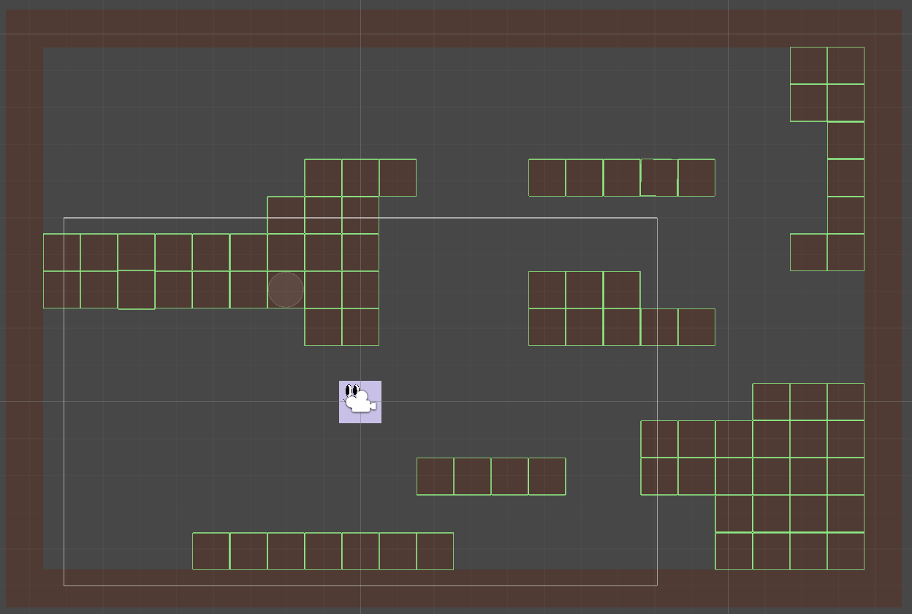

Select Breakable Blocks > BreakableBlock and key Use Ctrl + D to duplicate BreakableBlock within the Breakable Blocks object. This example uses 12 BreakableBlocks for BreakableBlock through BreakableBlock (11) since computers start counting at zero. Save your Project.

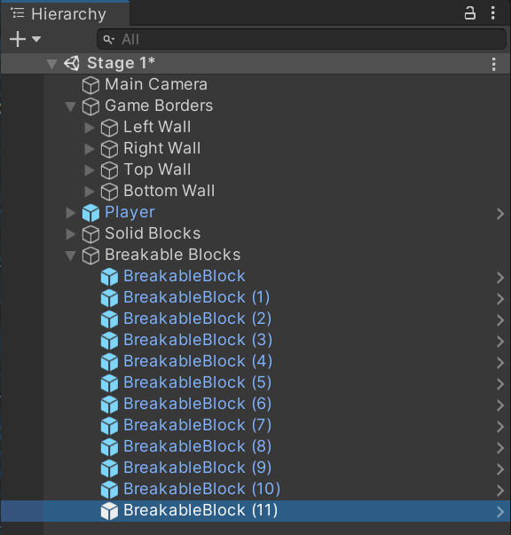

Next, position every BreakableBlock in the scene using the Rect Tool. The Downey Platformer Scene below, or your ideas and sketch inform placement and the number of BreakableBlock objects. If you lose track of BreakableBlock , double-click on either in Hierarchy to position them Scene center. Save your Project.



Congratulations on completing your first Milestone! In Milestone 2, you’ll be introduced to adding text against a background on the screen and work with the Unity UI Canvas.

Please proceed to

<https://www.oer4cte.org/downey_platformer_tutorials/milestone2_deliverable1.pdf>

and right click to

Save as…

and download the tutorial to your computer.